**CSE434 - Aspect- and Service-Oriented Software Systems**

**Lab 3**

|  |  |
| --- | --- |
| **Name** | Judy Khaled Mohamed Abdelmonem |
| **ID** | 20P6630 |

1. **Postman Screenshots:**

* **Create event**

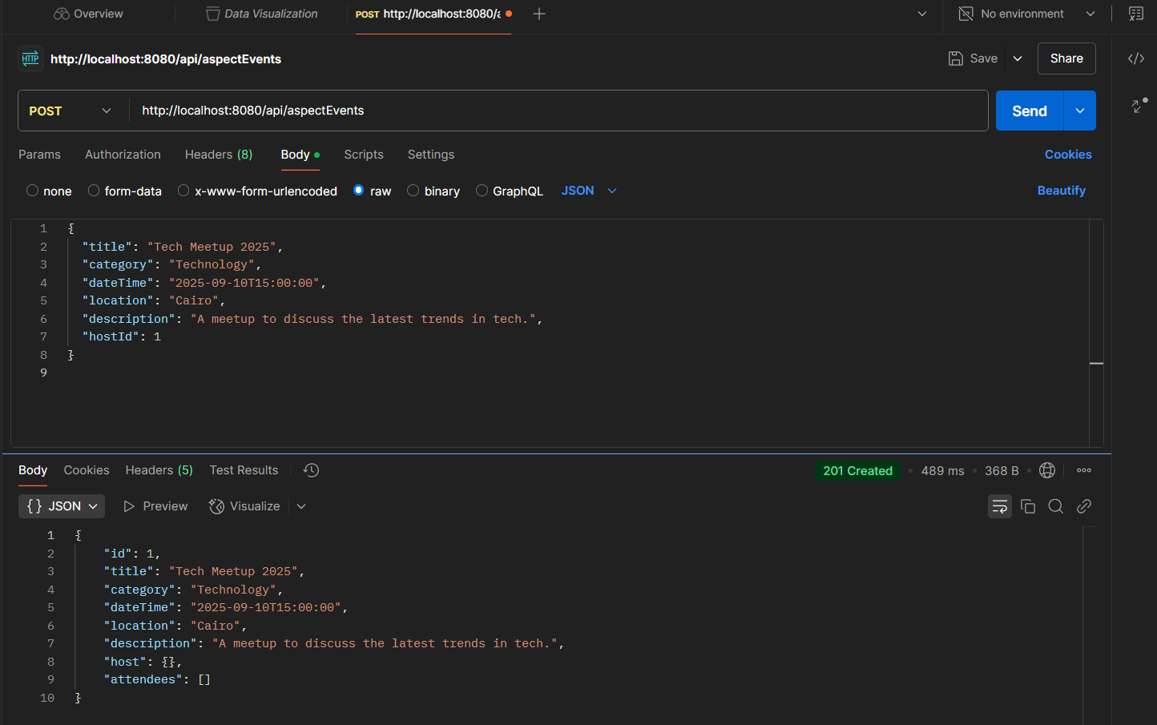

* **Retrieve all Events**

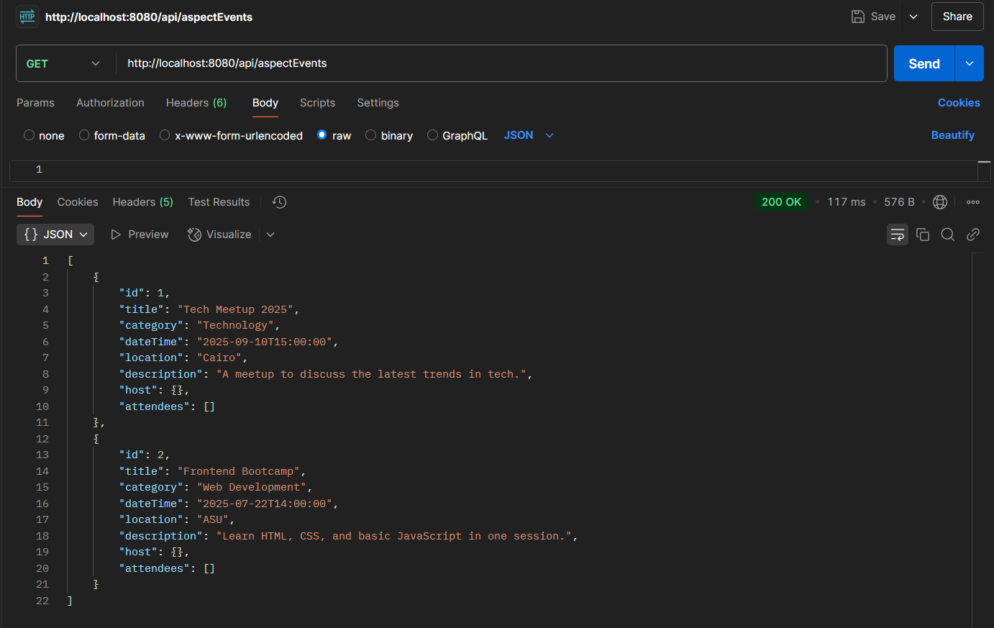

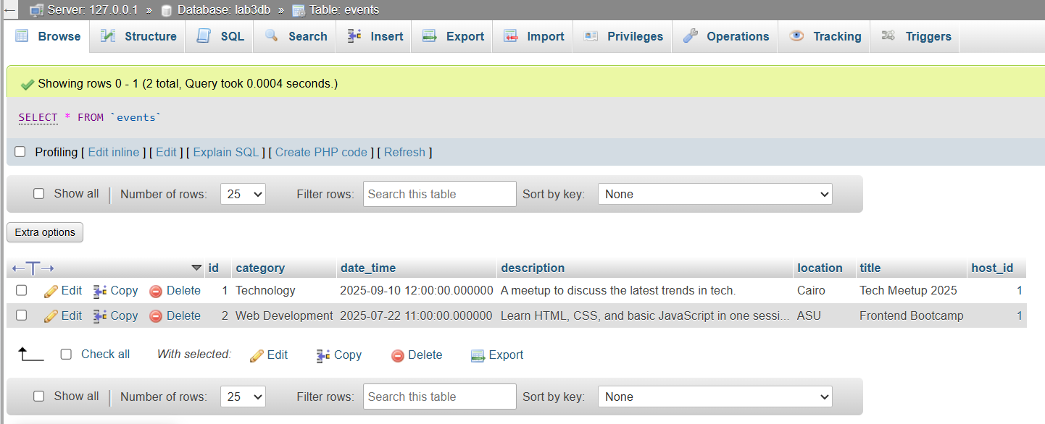

* **Get an event by ID**

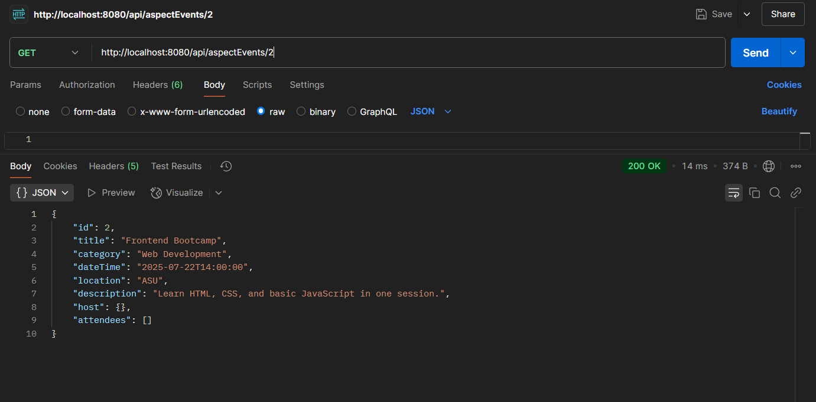

* **Update event**

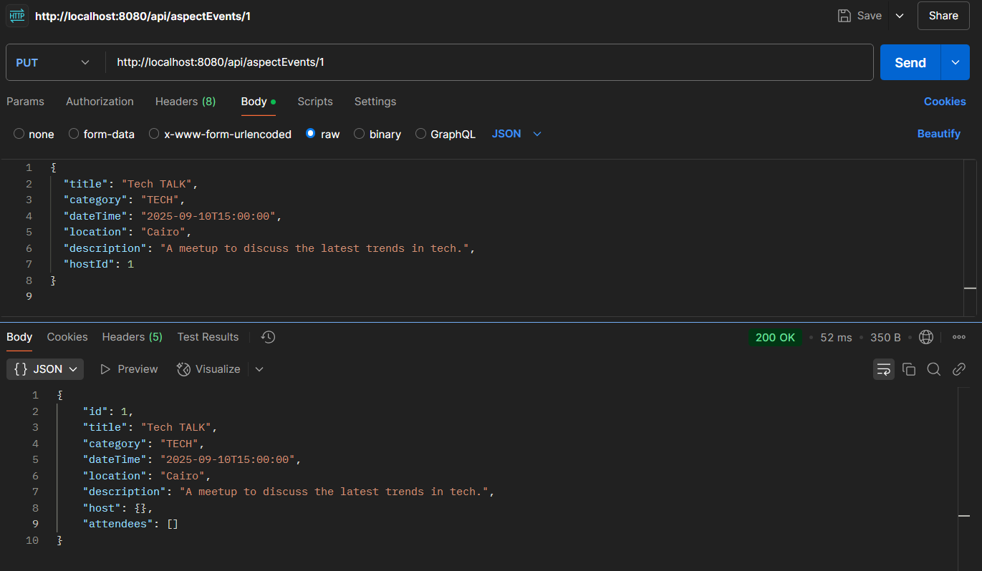

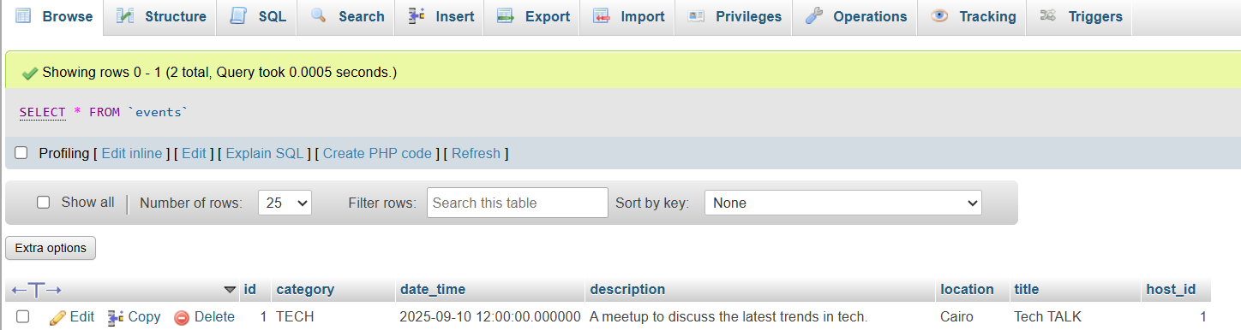

* **Delete event**

**Before:**

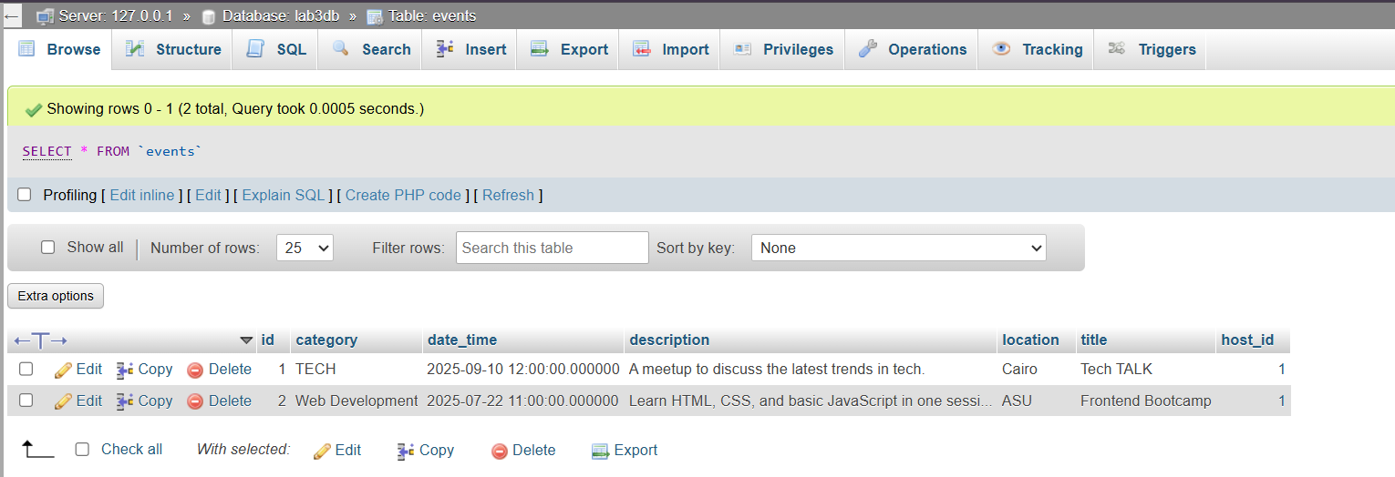

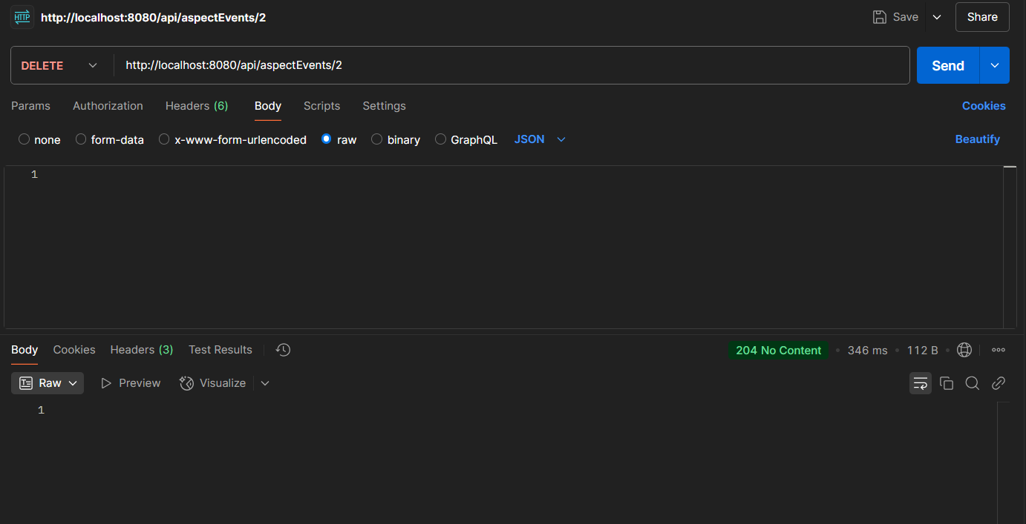

**After:**

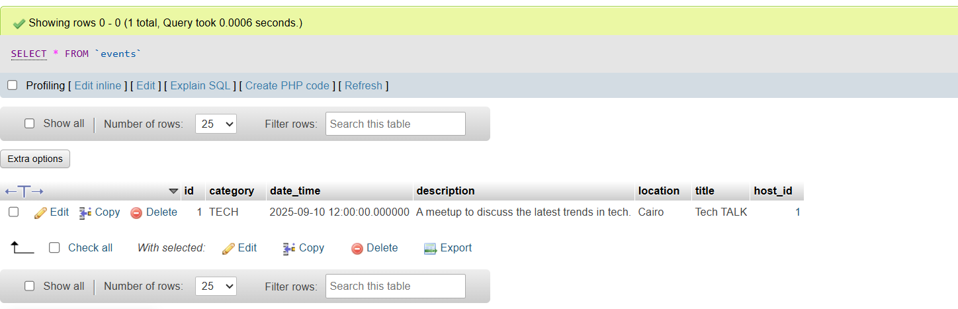

* **RSVP to Events (user id 1 will respond to attend event id 1)**

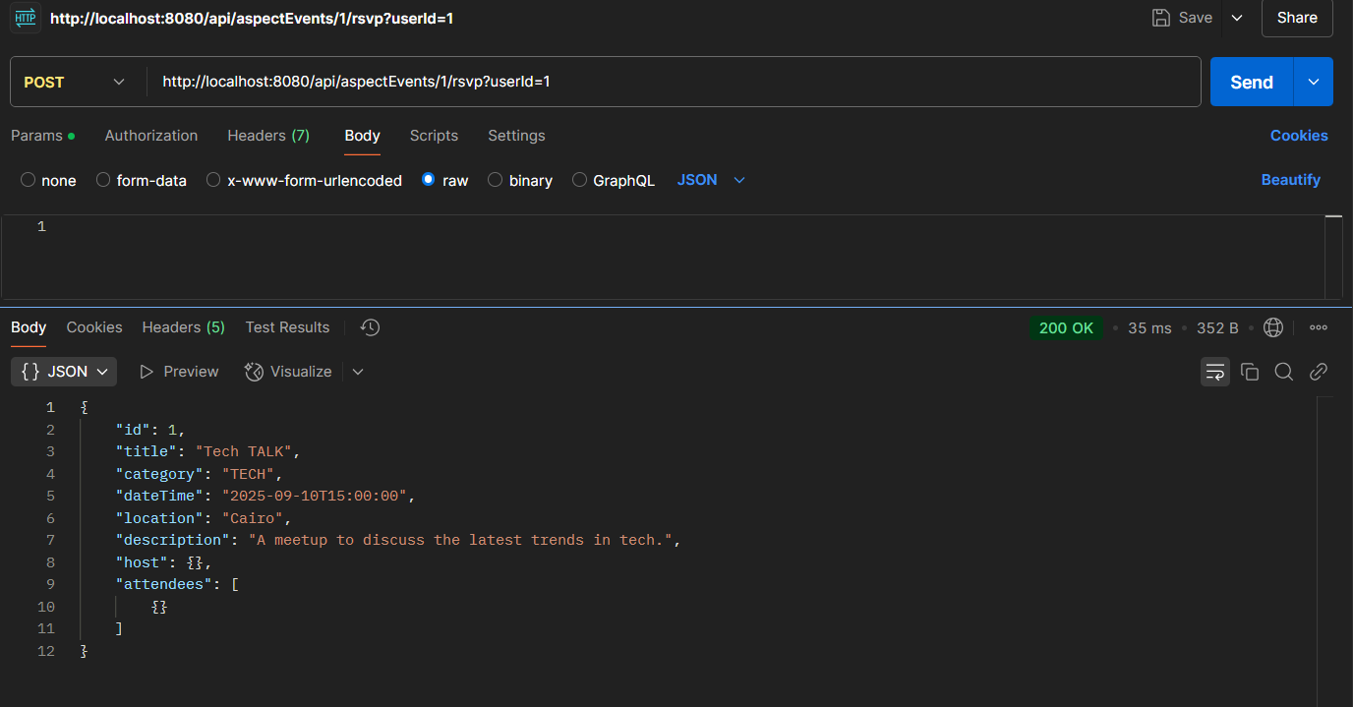

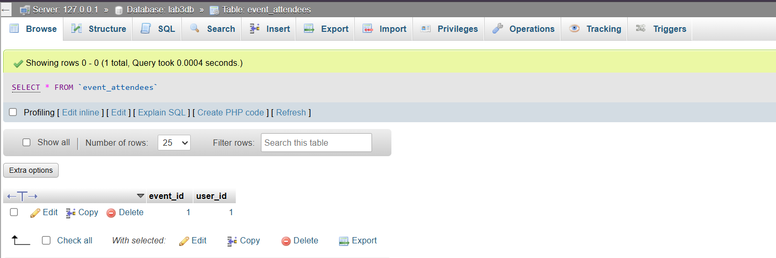

1. **Use docker-compose.yml to connect to mysql**

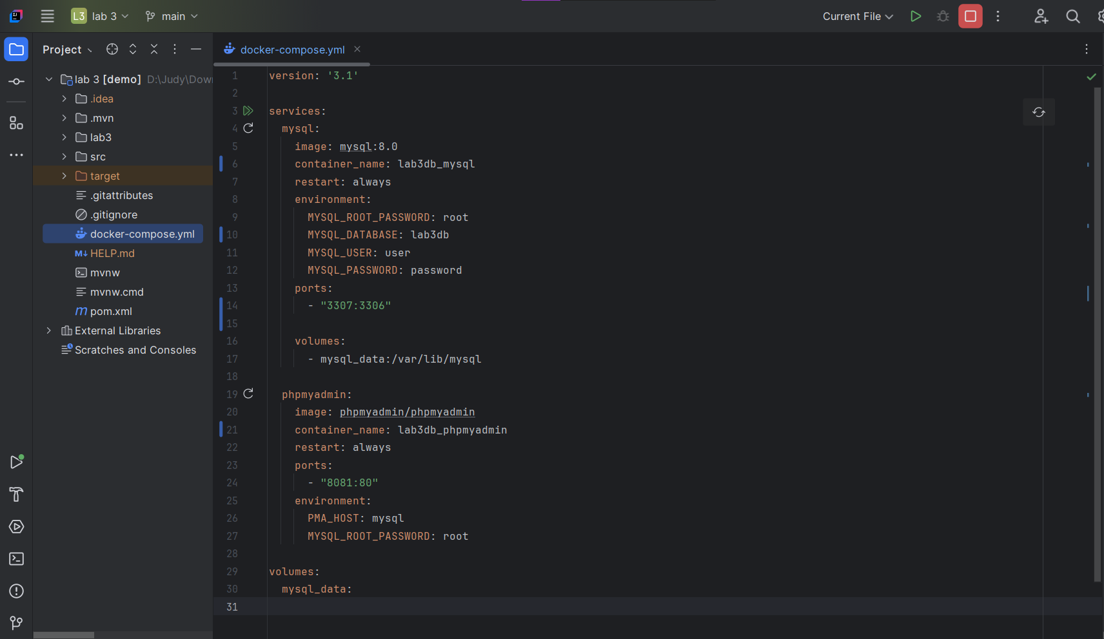

1. **relations between the two different entities in my database.**

**Relation 1 — Event hosted by a User (Many-to-One)**

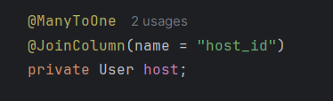

This means:

* Each event has one host (a user).
* Each user (host) can host multiple events.
* The column in the events table is host_id.

**Relation 2 — Event has many attendees (Many-to-Many):**

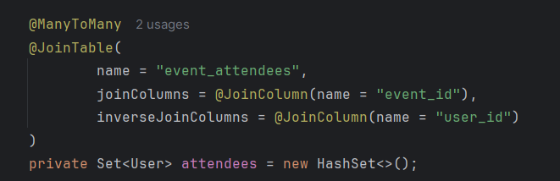

This means:

* Each event can have many users as attendees.
* Each user can attend many events.
* A join table event_attendees connects the two with event_id and user_id.

1. **GITHUB REPO LINK**

[**https://github.com/JudyKhaled/CSE-Aspect-Submissions.git**](https://github.com/JudyKhaled/CSE-Aspect-Submissions.git)